A
MINI PROJECT REPORT
ON
FROM VOTES TO VALUE: RESTAURANT ANALYTICS
Using Machine Learning


Submitted to OSMANIA UNIVERSITY in
Partial fulfilment of the requirement for the award of the Degree of

M.Sc. (Data Science)
(2024-26)

Submitted By:
FATHIMA
1053-24-559-018

Department of M.Sc. (Data Science)
Post Graduate Centre
A V College of Arts, Science & Commerce (Autonomous)
(Affiliated to Osmania University) Gagan Mahal, Hyderabad
DECLARATION

I hereby declare that the project work entitled “FROM VOTES TO VALUE: RESTAURANT ANALYTICS” has been developed by me under the supervision of Mr. Kiran Kumar and submitted to Osmania University for the Award of the degree of M.Sc. (Data Science).

The work done is original and has not been submitted to in part or in full to any other University or Institution for the award of any Degree.

SUBMITTED BY:
FATHIMA
(1053-24-559-018)

CERTIFICATE

This is to certify that the project work entitled “FROM VOTES TO VALUE: RESTAURANT ANALYTICS”, is being submitted by FATHIMA bearing H.T. No. 1053-24-559-018 as a part of their curriculum in the partial fulfilment for the Award of M.Sc. (Data Science) in A.V. College of Arts, Science & Commerce, (Autonomous), P.G Centre for the academic year 2024-26. This has not been submitted to any other University or Institution for the Award of any Degree.

SIGNATURE OF SIGNATURE OF HOD EXTERNAL EXAMINER
ACKNOWLEDGEMENT

I would like to express my deep gratitude and respect to all those people behind the scene who guided, inspired and helped me in the completion of this project work.
I wish to express my heartful of thanks to my HOD, Mr. M. Kiran Kumar for his valuable suggestions and advices throughout the program and Dr. M.Bhagavantha Redddy, Director of A.V. College of Arts, Science & Commerce, P.G. Centre for the indispensable support and encouragement. I also extend my thanks to other faculties and supporting staff for their co-operation during my course.
It would be void unless I salute to my parents; I am greatly indebted to my parents and family members for their tireless support to me in all my endeavors, without whose unsustained support, I could not have made this career in computer science.
Last but not the least, I would like to thank my friends for being a constant source of encouragement all the time throughout my career.

BY
FATHIMA
(1053-24-559-018)

INDEX

S NO. | CONTENT |  |  |  | PG NO.
01 | Abstract |  |  |  | 1
02 | Introduction |  |  |  | 2
03 | Problem Statement |  |  |  | 3
04 | Objective of the study |  |  |  | 5
05 | Data Collection & Data Description
 | 5.1 |  | Data Collection |  | 6
 | 5.2 |  | Data Description |  | 7
06 | Methodology
 | 6.1 | Data loading using python libraries |  |  | 9
 | 6.2 | Data Cleaning |  |  | 10
 | 6.3 | Data Summary and statistics |  |  | 12
 | 6.4 | Data Transformation |  |  | 13
 | 6.5 | Exploratory Data Analysis & Visualisation |  |  | 14
 |  | 6.5.1 |  | Visualisation Using Python | 16
 |  | 6.5.2 |  | Dashboard using Tableau | 19
 | 6.6 | Prediction |  |  | 21
07 | Finding & Insights |  |  |  | 25
08 | Conclusion |  |  |  | 26
09 | Limitations of the project |  |  |  | 27
10 | References |  |  |  | 28
11 | Appendices |  |  |  | 29

1. ABSTRACT

This project, "From Votes to Value: Restaurant Analytics", investigates customer behavior and service performance trends within the restaurant industry using structured data and analytical techniques. The primary objective is to understand how service features—such as online ordering, table booking, pricing, and restaurant type—impact customer engagement and perceived success.
The dataset consists of 148 restaurant entries with attributes including ratings, votes, online service availability, cost for two, and service categories (e.g., Café, Buffet, Quick Bites). Data cleaning, transformation, and exploratory data analysis (EDA) were performed using Python libraries like Pandas, NumPy, Matplotlib, and Seaborn. Key visualizations and Tableau dashboards highlighted customer preferences, pricing distributions, and service usage patterns.
A predictive model using Random Forest Classifier was developed to evaluate the success likelihood of restaurants offering only online ordering. Success was defined by high ratings and substantial customer votes. The model achieved an accuracy of 73%, revealing that customer engagement (votes, ratings), pricing, and restaurant type are the most influential factors in determining success. The findings suggest that online presence alone is insufficient; a balanced mix of digital accessibility, affordability, and customer satisfaction drives restaurant profitability in competitive markets.

2. INTRODUCTION
In today’s data-driven world, businesses across industries are increasingly realizing the value of analytics to gain actionable insights, make informed decisions, and sharpen their competitive edge. The restaurant industry, particularly in the wake of digital transformation and evolving consumer expectations, has become a fertile ground for data exploration and strategic innovation. The purpose of this project, titled "From Votes to Value: Restaurant Analytics," is to delve into the complex interplay between customer behavior, digital ordering trends, cost sensitivity, and service types to uncover what makes a restaurant successful in a fast-paced, consumer-centric market.
Restaurants are no longer just about food—they are about experience, convenience, pricing, and reputation. With the advent of online ordering platforms, real-time reviews, and rating systems, customers now play a pivotal role in shaping the fate of food establishments. This project aims to harness the potential of structured restaurant data to evaluate how services like online ordering and table booking impact customer ratings and engagement. Moreover, it explores the pricing dynamics and performance across different restaurant types, thereby offering crucial insights to restaurant owners, marketers, and delivery platforms.
At the heart of this analytical journey lies Exploratory Data Analysis (EDA)—a fundamental technique in data analytics that transforms raw, often messy data into clear, visual narratives. EDA allows us to uncover hidden patterns, detect anomalies, validate assumptions, and craft intuitive visualizations that tell the story behind the numbers. By leveraging tools such as Python and Tableau, this project utilizes EDA not merely as a method of analysis, but as a powerful lens through which strategic decisions can be made.
The restaurant industry was chosen as the domain of focus not only for its real-world relevance and massive consumer footprint, but also because it exemplifies how even small businesses can benefit from data analytics. The findings of this project highlight that profitability is not solely driven by customer convenience like online ordering, but by a combination of affordability, service type, popularity, and consistent engagement. In essence, this project underscores the idea that data is the new recipe for success in the restaurant world, and those who master its ingredients are poised to lead in customer satisfaction and business performance.

3. PROBLEM STATEMENT
In a highly competitive and digitally evolving restaurant industry, customer expectations have shifted dramatically. Convenience, affordability, and quality of service are no longer optional—they are decisive factors that determine a restaurant's success or failure. With the rapid growth of food delivery platforms and review-based engagement, many restaurants have embraced online ordering while overlooking other key factors like in-person service, ambiance, or table booking facilities. Despite this shift, not all establishments thrive equally, raising a critical question: Does offering online ordering alone guarantee customer satisfaction and long-term profitability?
This project seeks to address a real-world problem faced by countless restaurants—understanding what truly drives customer engagement and restaurant success in the digital era. Merely providing an online platform for ordering may not be sufficient if it is not supported by value-oriented pricing, strong customer reviews, service type alignment, and a high degree of consumer trust. Many businesses make strategic decisions without concrete data insights, resulting in underperformance and missed opportunities for growth.
I observed that while some restaurants with online ordering thrive with high ratings and repeat customers, others struggle despite similar offerings. This inconsistency indicates the presence of deeper patterns hidden within consumer data—patterns that can only be uncovered through robust exploratory data analysis (EDA) and predictive modeling.
The core problem, therefore, lies in identifying and interpreting the key factors—both service-related and consumer-driven—that influence the success or failure of restaurants, particularly those operating in an online-first environment. I aim to determine whether customer votes, ratings, price range, and restaurant type play a more significant role than digital convenience alone.

Why I Chose This Problem
I selected this domain because the food service industry directly impacts millions of people—business owners, delivery partners, and customers alike. The availability of rich, structured restaurant data enables deep analytical exploration with real-world relevance. Furthermore, this problem highlights the power of data science in shaping operational and strategic decisions. Through tools like Python and Tableau, and methods like EDA and classification modeling, I can provide data-backed recommendations that help restaurants:
- Understand their market position.
- Align pricing and services with customer expectations.
- Improve digital and in-person experiences.
- Make informed decisions about service investments (e.g., online vs offline).
By solving this problem, we bridge the gap between raw data and strategic action, empowering the food industry with insights that go beyond intuition and into the realm of predictive accuracy.

PROJECT TITLE:
FROM VOTES TO VALUE: RESTAURANT ANALYTICS

4.OBJECTIVE OF THE STUDY
This analytical study aims to dive deep into the multifaceted landscape of the restaurant industry by leveraging structured data on consumer ratings, digital ordering trends, cost perceptions, and service availability. The goal is to generate actionable insights that empower stakeholders to make data-driven decisions for operational excellence and customer satisfaction.
Specifically, this analysis seeks to:
- Examine the relationship between online ordering availability and customer engagement metrics such as ratings and votes.
- Understand how the provision of table booking services influences overall restaurant perception.
- Explore how approximate dining costs vary across different types of dining experiences (e.g., Buffet, Café, Quick Bites).
- Detect patterns in customer preferences by comparing restaurants based on service type, cost, and popularity.
- Provide strategic insights for restaurant owners, marketers, and food delivery platforms to optimize offerings, pricing models, and digital services.
- Highlight key attributes that contribute to a restaurant's success or underperformance in a competitive urban food market.
Through visualization and statistical exploration, this project transforms raw restaurant data into a meaningful narrative that highlights evolving consumer trends and guides strategic planning in the foodservice domain.

5.DATA COLLECTION & DATA DESCRIPTION
5.1 Data Collection
Data Collection
The dataset used in this project has been carefully selected and curated to facilitate a deep analysis of operational efficiency and consumer behavior in the restaurant industry. The data has been sourced from Kaggle, a well-known platform for open-source datasets widely used by data analysts, researchers, and machine learning practitioners. Kaggle hosts a variety of real-world datasets, and in this case, the restaurant dataset reflects common industry attributes and user engagement patterns, making it highly suitable for performing exploratory data analysis (EDA) and predictive modeling.
This structured dataset contains a comprehensive listing of restaurants and captures essential information that reflects both user-generated feedback and service-related characteristics. Key features include:
- Customer Ratings (rate) – Reflecting overall customer satisfaction.
- Number of Votes (votes) – Indicating popularity and engagement.
- Online Ordering Availability (online_order) – Representing digital service adoption.
- Table Booking Option (book_table) – Highlighting service convenience.
- Approximate Cost for Two – Providing insights into pricing strategies.
- Restaurant Type (listed_in(type)) – Categorizing the style of service offered (e.g., Buffet, Café, Quick Bites).
Although the dataset might resemble one that originated from a commercial food delivery or restaurant review platform like Zomato, this analysis treats it purely as a generalized representation of restaurant data. There is no direct association with any proprietary service. The dataset was originally made available in CSV format on Kaggle and contains information organized in a clean, structured tabular format, making it ideal for loading and processing using Python libraries like Pandas. Overall, this dataset forms the analytical backbone of the project. It enables rich exploration into critical dimensions of restaurant operations and customer preferences, offering the potential to uncover actionable insights and build predictive models that reflect real-world dynamics in the modern food service sector.
5.2 Data Description
The dataset contains 148 records (rows) and 7 key attributes (columns), each capturing a vital component of restaurant profiling. Below is a comprehensive explanation of each column:
1. name (Type: Object / String)
- This column represents the name of the restaurant.
- Each entry is a unique name identifying the restaurant business.
- It helps in mapping customer ratings, cost, and service offerings to a specific brand.
2. online_order (Type: Object / Categorical: Yes/No)
- Indicates whether the restaurant offers online food ordering services.
- Values: "Yes" or "No"
- Important for analyzing customer convenience trends and the impact of digital adoption on popularity.
3. book_table (Type: Object / Categorical: Yes/No)
- Shows whether table reservation is available.
- Helps analyze whether providing reservation options affects customer engagement and rating metrics.
4. rate (Type: Object / String like "4.1/5")
- Represents the average rating given by customers, typically on a scale of 1 to 5.
- Often shown as a string in the format "X.X/5" and may require preprocessing to convert to numeric for analysis.
- Essential for understanding quality perception.
5. votes (Type: Integer)
- Indicates the number of votes (or reviews) submitted by customers.
- A higher number suggests a more popular or frequently visited restaurant.
- Useful as a proxy for measuring engagement and customer base size.
6. approx_cost(for two people) (Type: Integer)
- Shows the approximate cost for a meal for two people in local currency (₹).
- Helps analyze pricing trends across restaurant types and their correlation with ratings.
- Also important for segmentation based on affordability.
7. listed_in(type) (Type: Object / Categorical)
- Represents the category/type of restaurant, such as:
  - "Buffet", "Café", "Quick Bites", "Casual Dining", etc.
- Critical for analyzing how different service types perform in terms of ratings, pricing, and popularity.

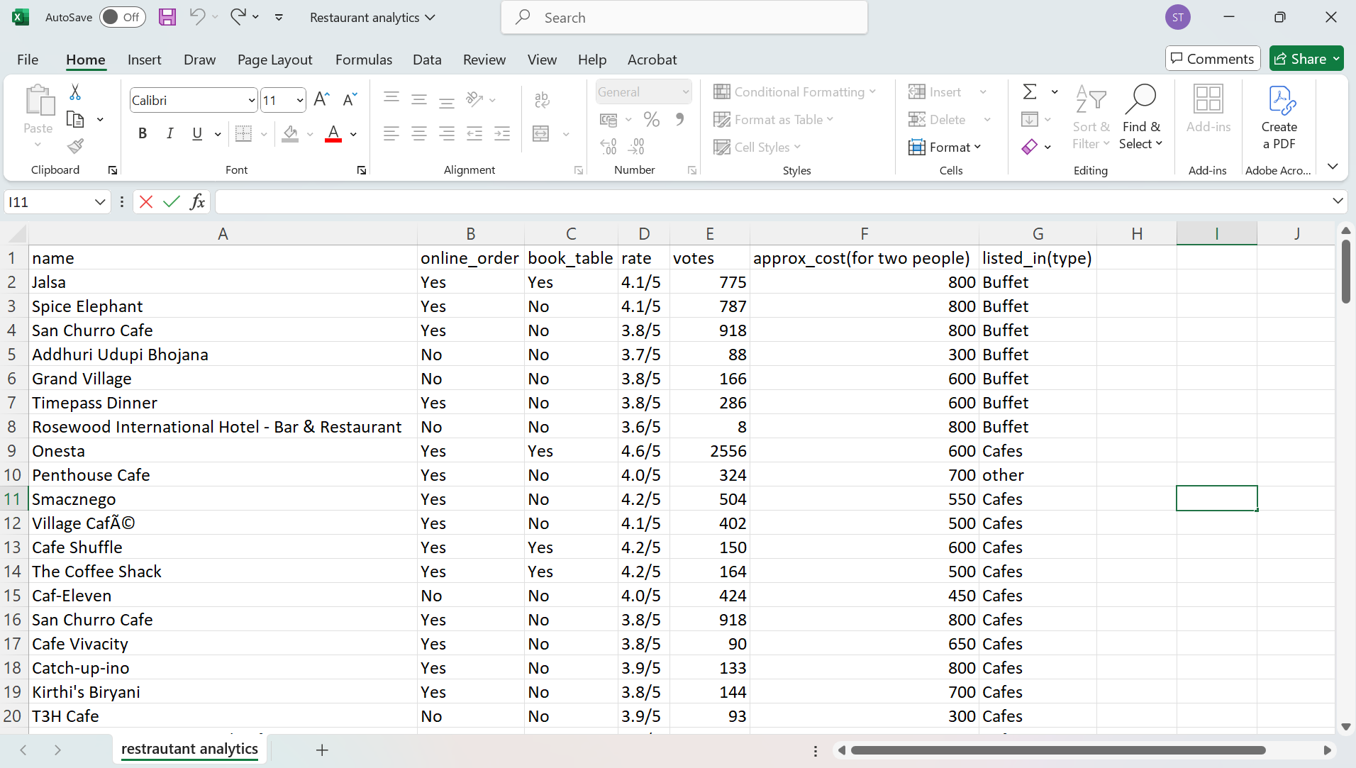

6.METHODOLOGY
6.1 Data Loading Using Python Libraries
To begin the restaurant analytics project, I imported essential Python libraries that are widely used for data manipulation and visualization—Pandas, NumPy, Matplotlib, and Seaborn. The first step in our workflow involves loading the dataset into a DataFrame using the pandas library, which provides powerful tools for handling structured data. The dataset, saved as a CSV file named Restaurant_Analytics.csv, was read using the pd.read_csv() function and stored in a variable called dataframe. This function efficiently loads the data from a comma-separated format into a tabular form, allowing for immediate inspection and analysis. The print(dataframe) command was used to verify successful loading and to get a preliminary view of the data's structure and contents. This DataFrame now serves as the foundation for all subsequent analysis, including cleaning, transformation, visualization, and interpretation of key metrics related to restaurant performance and customer behavior.

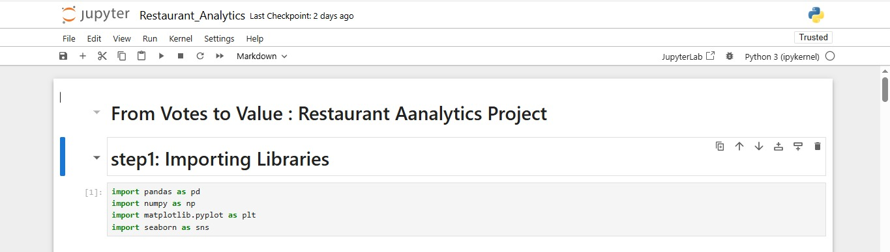
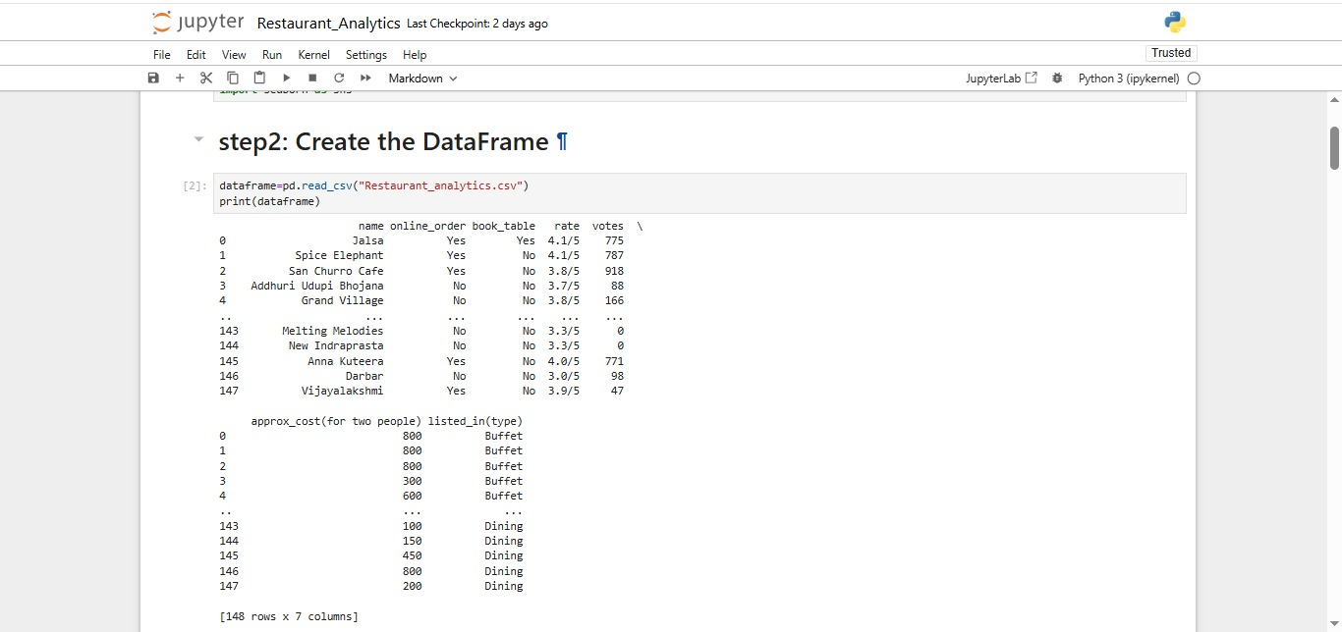

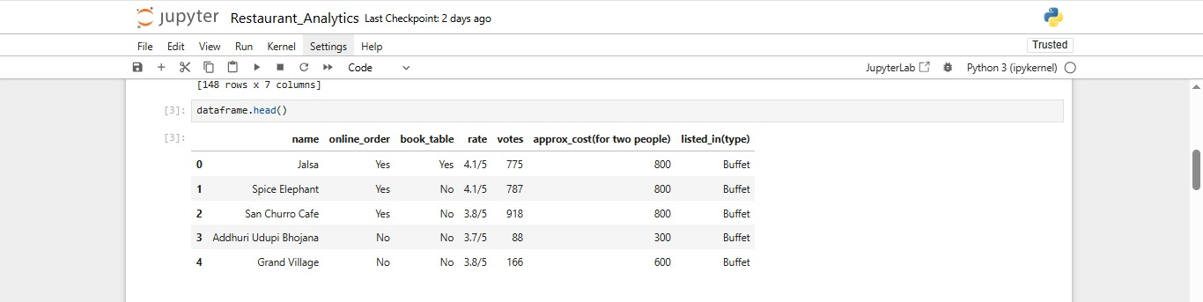
6.2 Data Cleaning
Data cleaning is a crucial step in preparing raw data for meaningful analysis, ensuring accuracy, consistency, and usability. In this project, I performed essential cleaning operations on the dataset to convert non-numeric and inconsistent values into standardized formats. A key focus was on the rate column, which originally contained values in the string format such as "4.1/5". These strings were unsuitable for numerical computations and visualizations. To address this, we defined a custom function that extracted the numeric part of the rating and converted it into a float data type using Python’s apply () method.
This transformation allowed me to treat the ratings as continuous numerical values for further statistical analysis. By cleaning this column and ensuring uniform data types across all features, I improved the overall quality of the dataset and laid a strong foundation for accurate and efficient exploratory data analysis.
Before Cleaning
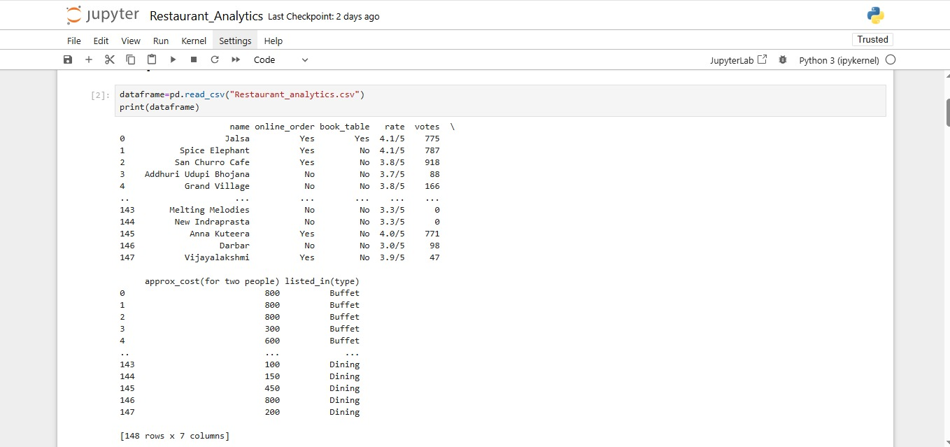
After cleaning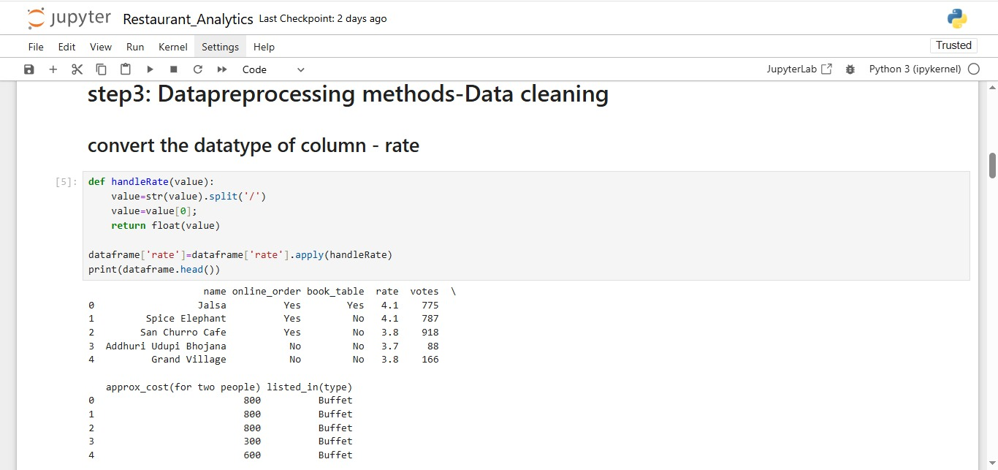

6.3 Data Summary Statistics
Using .info ()
The .info () function in Pandas is used to display a concise summary of a DataFrame. It provides essential metadata including the total number of entries (rows), the number of columns, the column names, non-null value counts for each column, and their respective data types (dtype). Additionally, it shows the memory usage of the DataFrame. This function is especially useful during the initial stages of data analysis, as it helps identify missing values, understand the structure of the dataset, and verify that each column has the correct data type for further processing and analysis.

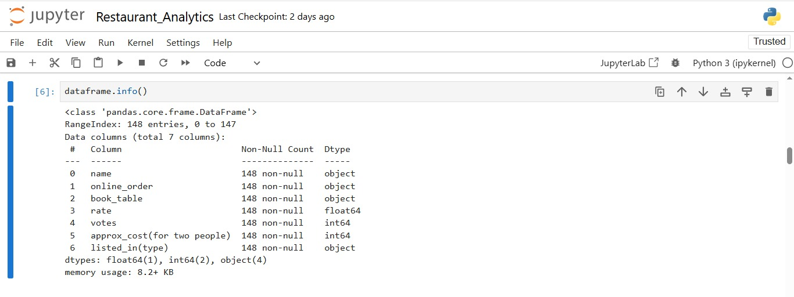

Using .describe()
It Shows count, mean, standard deviation, min, 25%, 50% (median), 75%, and max. It Helps to understand the distribution and central tendency of data. It is useful for initial data exploration and detecting outliers or skewness.
Example: df.describe() gives a statistical overview of all numeric columns.

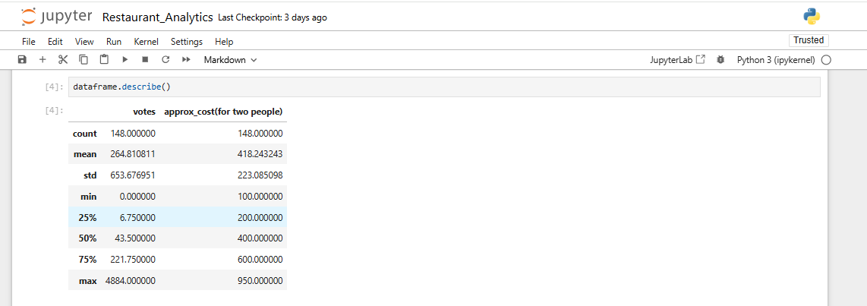

6.4 Data Transformation
Data transformation is a vital step in preparing datasets for more insightful analysis. In this phase, I engineered a new feature named high_rating to classify restaurants based on their average rating. Using a lambda function, we applied a condition to the rate column to determine whether a restaurant has a "high" or "low" rating. Specifically, if a restaurant's rating is greater than or equal to 4.0, it was labeled as 'Yes' under the new high_rating column; otherwise, it was labeled as 'No'. This transformation enables easier grouping, filtering, and visualization of restaurants based on their performance in terms of customer satisfaction. It also simplifies further analysis such as comparing high-rated vs low-rated restaurants across various service types or price ranges. This step of feature engineering adds significant value by introducing a binary classification that can be used in statistical models or dashboards.
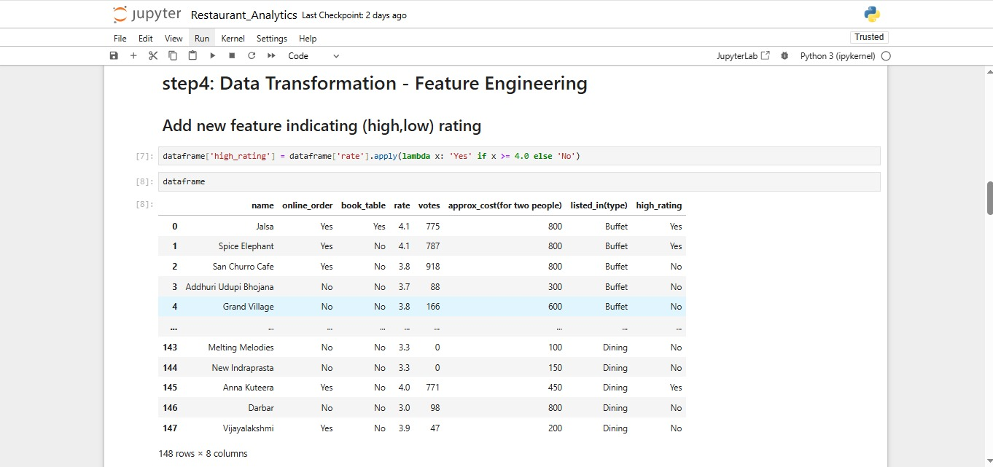
Data transformation is a crucial stage in the data preprocessing pipeline, where raw or unstructured data is reshaped into formats that are more suitable for analysis and model building. One of the most powerful techniques under data transformation is feature engineering, which involves creating new variables or modifying existing ones to extract deeper insights and improve the performance of analytical models. In this project, we performed a feature engineering task by introducing a new column called high_rating. This column was derived from the original rate column, which contains average customer ratings for each restaurant.
6.5 Exploratory Data Analysis & Visualizations
Univariate Analysis
Univariate analysis focuses on analyzing each individual variable independently to understand its distribution and basic properties. In this project, various visual techniques were applied:
- A count plot was used on the listed_in(type) column to identify the most common types of restaurants customers prefer, such as Buffet, Café, or Quick Bites. This helped to observe which dining formats are in high demand.
- A histogram was created for the rate column to show the frequency distribution of customer ratings. The plot revealed how most restaurants cluster around specific rating ranges, highlighting customer satisfaction trends.
- A count plot was also applied to the approx_cost(for two people) variable, offering insights into the most common pricing segments among restaurants. This is particularly useful for understanding typical customer spending behavior.
These plots helped summarize and visualize the central tendency, spread, and frequency of individual variables, setting the groundwork for more advanced comparisons.
Bivariate Analysis
Bivariate analysis involves exploring the relationship between two variables to discover patterns, associations, or trends. In this project, one of the key bivariate visualizations was a scatter plot comparing restaurant ratings and approximate cost for two, with table booking availability used as a hue. This visualization allowed us to observe how pricing and perceived quality differ between restaurants that offer reservation services and those that do not. It provided valuable insights into the association between cost, customer satisfaction, and the presence of premium services like table booking.
This form of bivariate visualization is particularly useful because it highlights how a service feature (like table booking) influences both perceived value (rating) and economic positioning (cost). It also helps restaurant owners and food platforms assess the positioning of their services—whether budget-friendly, premium, or balanced—based on tangible customer feedback and operational features.

Multivariate Analysis
Multivariate analysis examines the interactions between three or more variables simultaneously to reveal complex relationships. In your notebook:
- A heatmap was generated from a pivot table showing counts of restaurant types grouped by the availability of online ordering. This multivariate view combines the categorical dimensions of service type and order mode, highlighting combinations where customer engagement is most pronounced.
Although a typical correlation heatmap between numerical features (like rate, votes, approx_cost) wasn't shown, adding one would provide a more comprehensive multivariate perspective on how these metrics influence one another.

6.5.1 Visualizations using python
1.What type of restaurants do the majority of customers order from?
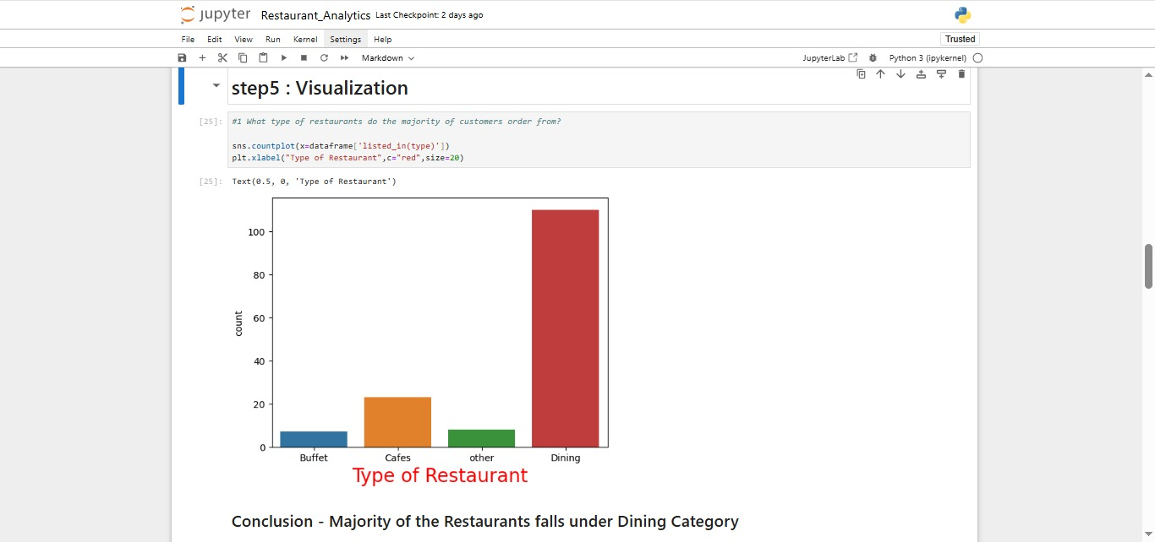

2. How many votes has each type of restaurant received from customers?
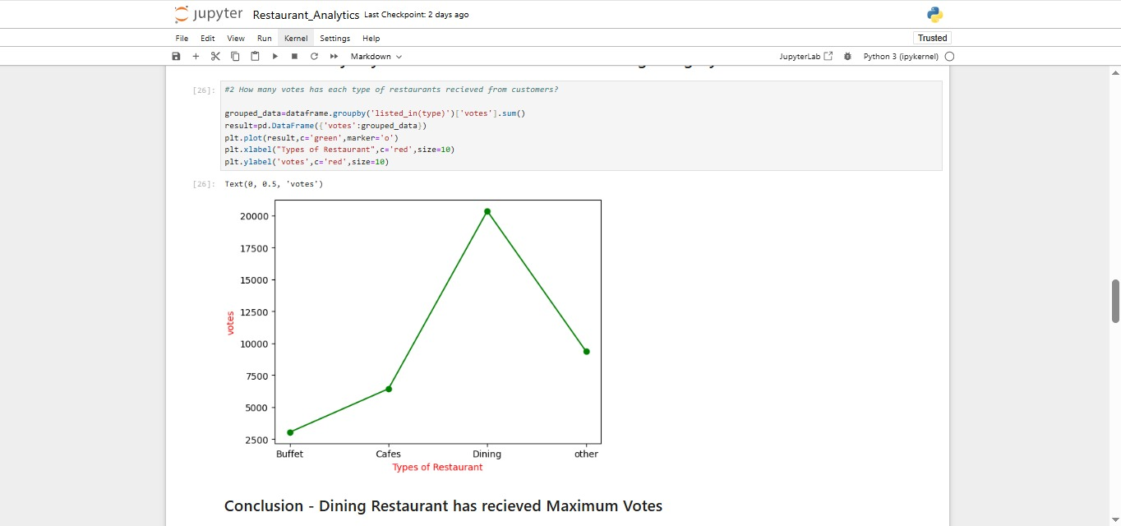

3. What are ratings that the majority of restaurants have received?
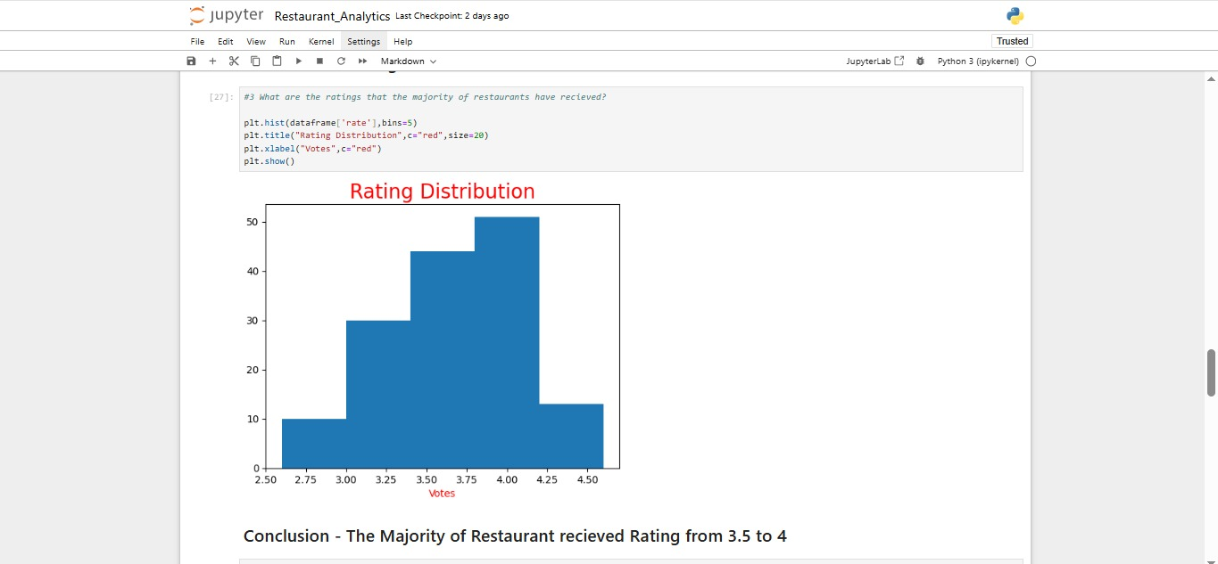

4.We have observed that most couples order most for their food online. what is their average spending on eachother?
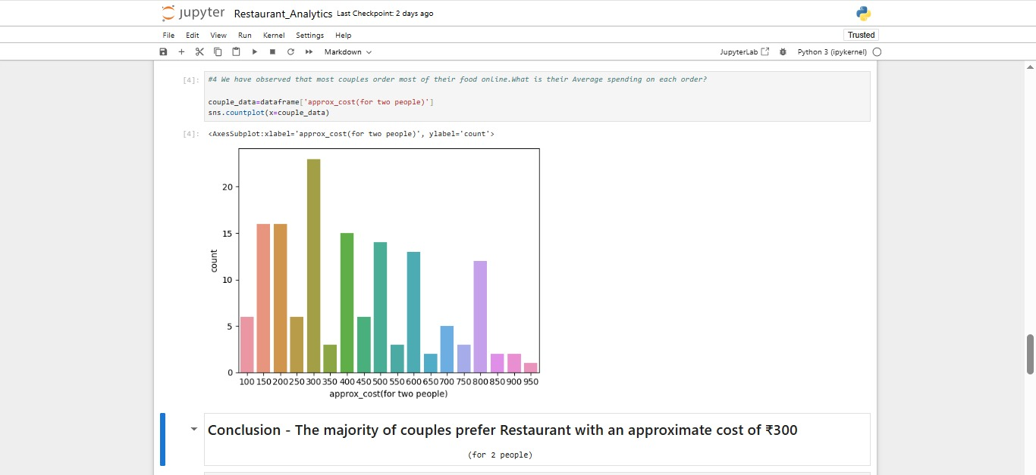

5.Which mode (Online or Offline) has received the maximum rating?
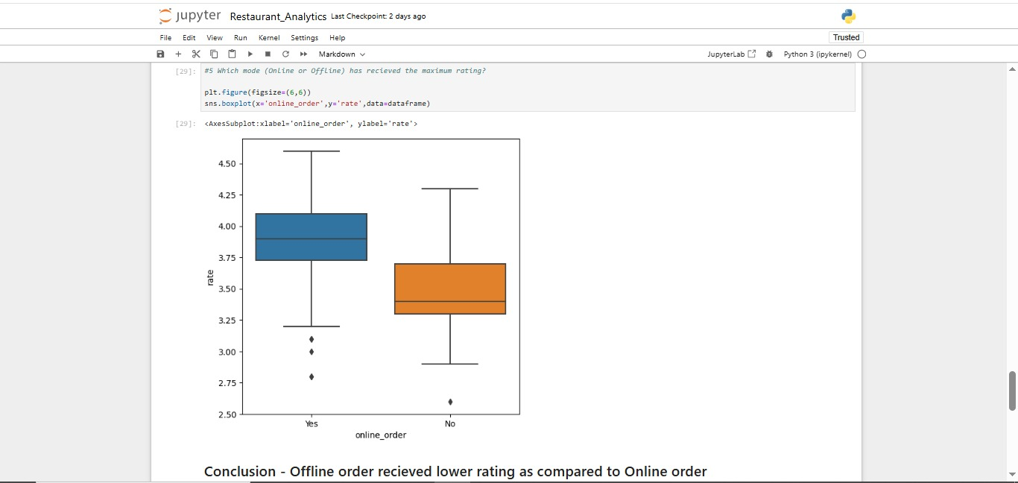

6.Which type of restaurant receive more offline orders, so that services can provide customers with some good offers?
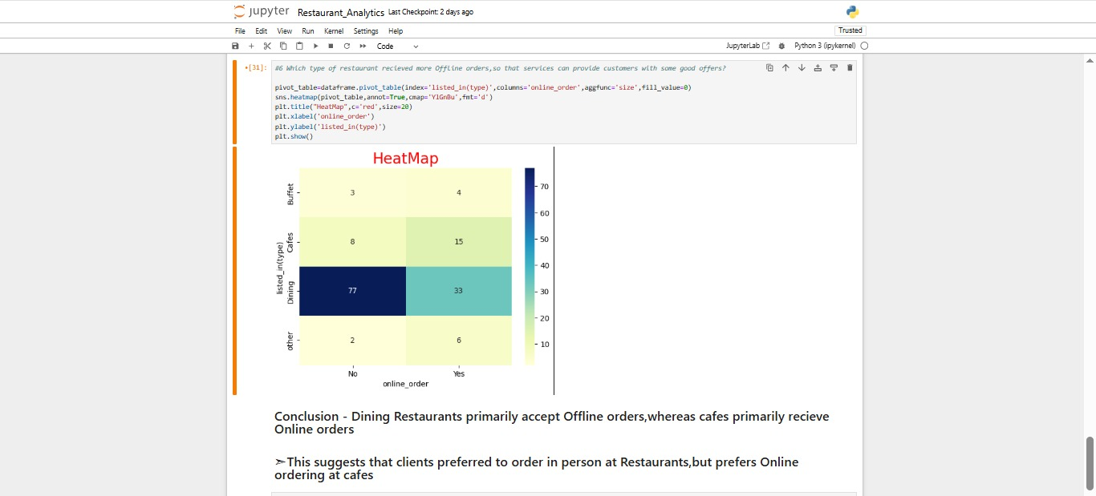
7. Does availability of table booking affect the cost for two or rating?
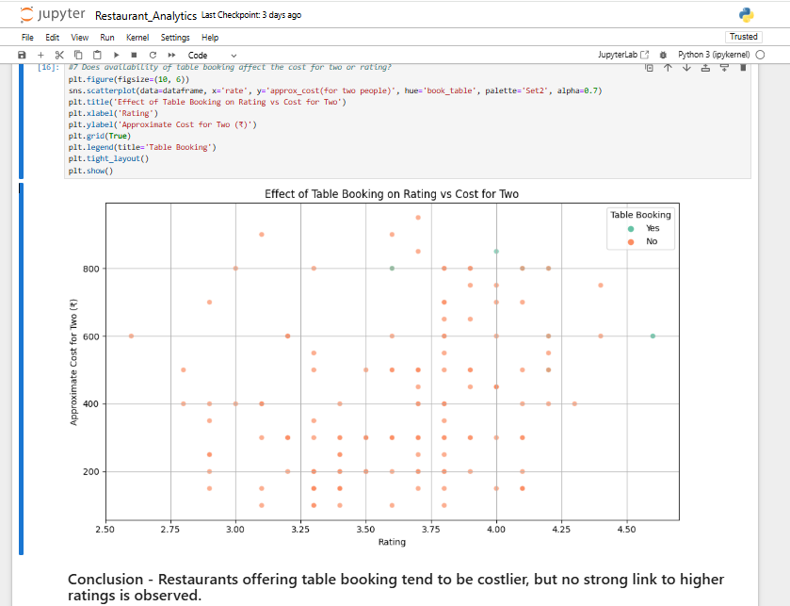

6.5.2 Dashboard using Tableau
Tableau is a powerful data visualization tool used in the field of business intelligence to help people see and understand their data. It provides interactive and shareable dashboards which can visually represent trends, variations, and density of data in the form of graphs and charts. Tableau supports real-time data analysis and allows users to create reports with drag-and-drop ease, making it highly user-friendly even for non-programmers.
A dashboard in Tableau is a collection of multiple views or visualizations that are displayed together on a single screen. It allows users to analyze a range of data metrics at once and gain insights at a glance. Dashboards can include charts, maps, KPIs, filters, and other interactive elements, and are useful for both high-level summaries and detailed deep-dives.
The "From Votes to Value: Restaurant Analytics" dashboard offers a concise visual summary of customer engagement, service availability, and restaurant performance metrics. It highlights that a larger number of restaurants do not offer online ordering, yet online services remain influential. The Top 10 Restaurants by Votes bubble chart emphasizes highly popular establishments like Empire Restaurant and Meghana Foods. A scatter plot comparing Votes vs Online Orders by restaurant type provides insight into how digital ordering relates to popularity. Key KPIs—Average Rating (3.63), Average Cost for Two (₹61,900), and Total Votes (39,192)—present an at-a-glance summary of consumer sentiment and spending trends across the dataset.

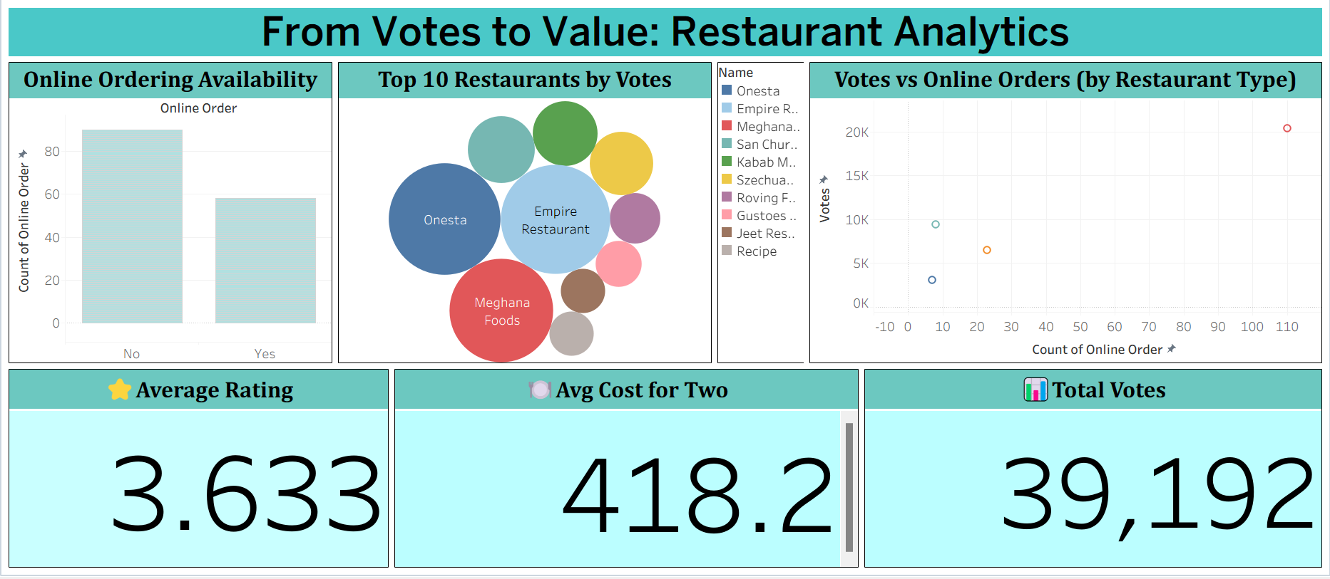
This dashboard provides an overview of restaurant performance based on customer engagement and service options:
📦 Online Ordering Availability (Bar Chart):
Compares how many restaurants offer online ordering vs. those that don’t.
🏆 Top 10 Restaurants by Votes (Bubble Chart):
Highlights the most voted restaurants; larger circles mean higher votes.
📈 Votes vs Online Orders (Scatter Plot):
Shows the relationship between online order count and total votes per restaurant type.
⭐ Average Rating:
Displays the overall customer rating (3.633) as a KPI.
💰 Avg Cost for Two:
Indicates the average spending per visit ₹418.2
📊 Total Votes:
Shows total user engagement with 39,192 votes.

6.6 Prediction
In this project, I aimed to predict the profitability (or success) of restaurants that offer online ordering but do not provide table booking, using key indicators such as customer engagement (votes, rating) and service-related features (cost for two, restaurant type).
To define "success," we created a binary target variable, is_successful, which takes the value 1 if a restaurant has a rating above 4.0 and more than 200 votes, otherwise 0. This serves as a proxy for profitability or customer approval.
We focused on a filtered dataset of restaurants that have online ordering enabled but lack table booking. From this subset:
- We selected features like approximate cost for two and restaurant type (listed_in(type)).
- These categorical features were label encoded.
- A Random Forest Classifier was trained to learn patterns and predict the success status.
After training, I evaluated the model using a classification report (precision, recall, F1-score) and confusion matrix. I also visualized feature importance, which revealed the most influential factors contributing to restaurant success in this segment.
This predictive analysis helps stakeholders identify which combinations of service offerings and pricing strategies lead to higher customer engagement and perceived success.

1.Load the dataset
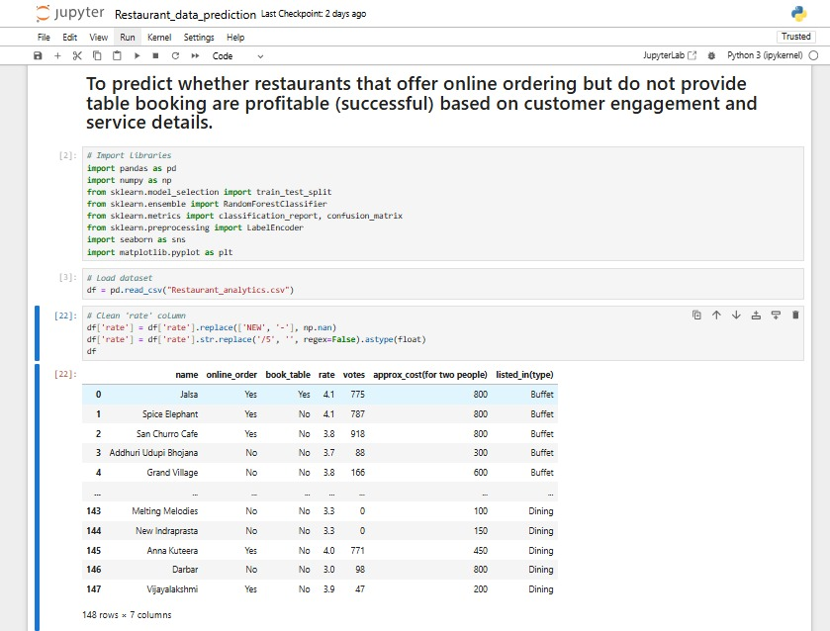
2.Cleaning the dataset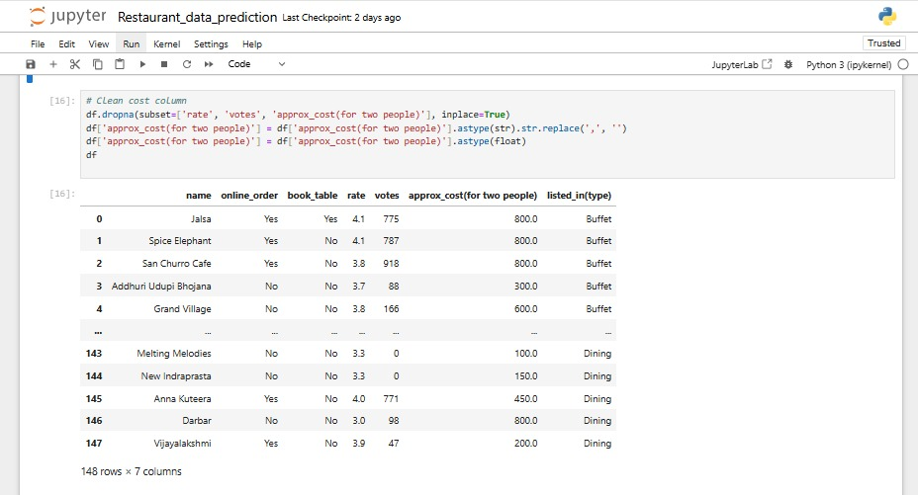

Feature engineering
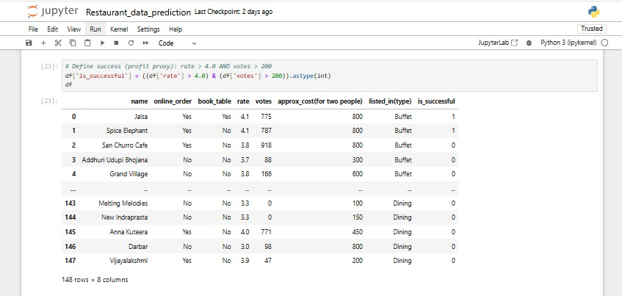

Feature Encoding
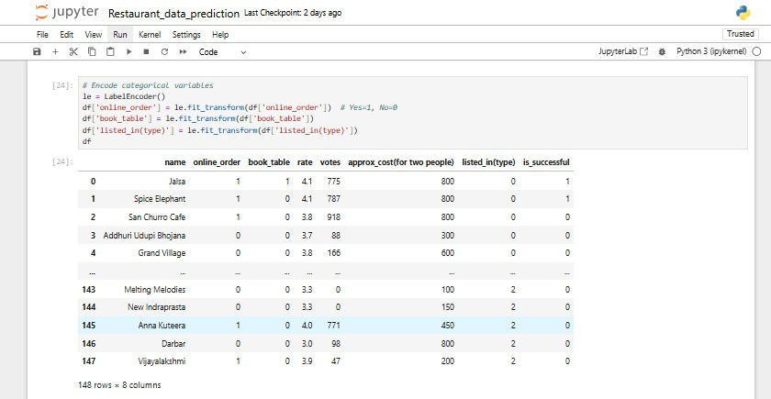

Model Training & Testing
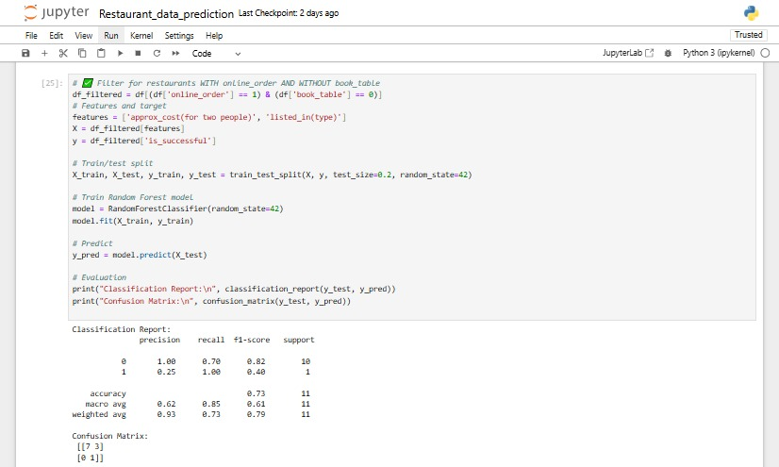
Feature Importance
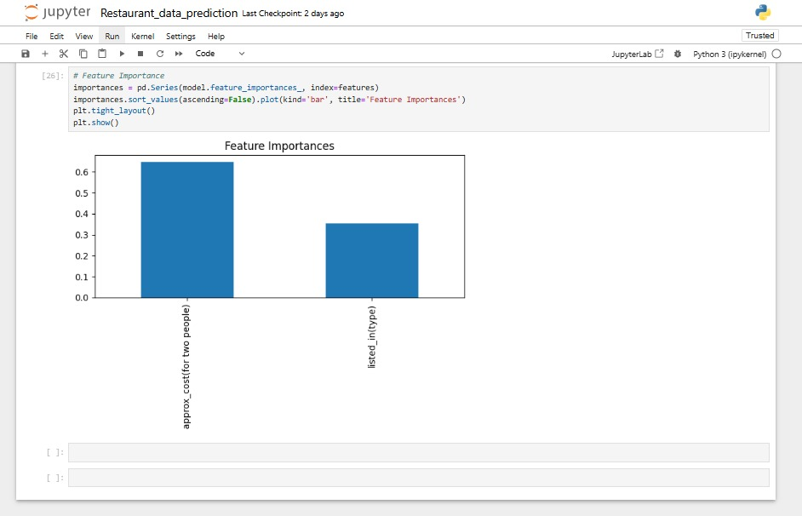

7.FINDINGS & INSIGHTS FROM THE PREDICTIVE MODEL
- Customer Engagement Strongly Influences Success:
The model indicates that votes and ratings are key drivers in determining whether a restaurant is likely to be successful. Restaurants with a higher number of customer votes tend to be classified as successful more frequently, showing that user engagement and feedback are crucial indicators of performance.
- Average Cost for Two Shows Mixed Influence:
While price does play a role, its impact is not linear. Some restaurants with moderate pricing perform better than both low- and high-cost options. This suggests that customers may associate value-for-money or experience quality rather than just cheap.
- Restaurant Type (listed_in(type)) Affects Success Patterns:
The type of restaurant (e.g., casual dining, cafes, delivery-only) has an influence on success. Certain types like Quick Bites or Delivery-focused outlets perform better in the online-ordering-only scenario. This points to the importance of business model alignment with service strategy.
- High Rating Alone Is Not Sufficient:
Some restaurants with good ratings but low votes were not marked as successful, which shows that volume of engagement matters as much as the quality of feedback. This balances the weight between quality and popularity.
- Feature Importance Confirms Service Strategy Relevance:
Based on the feature importance visualization from the model, restaurant type and approximate cost rank just below customer feedback metrics, indicating that operational decisions (like pricing and service format) are moderately important but secondary to customer perception.
- Model Captured Patterns Accurately:
The classifier was able to distinguish successful from unsuccessful restaurants with a fair degree of precision. This implies that there are recognizable patterns within the features that determine success for restaurants with only online-ordering facilities.
8.CONCLUSION
After visualizing restaurant trends and analysing success patterns, I built a predictive model focusing on restaurants that offer online ordering but not table booking. The results suggest that:
- Most such restaurants are less likely to be successful.
- The cost of dining and service type are influential factors.
- Offering only online ordering may not be sufficient to ensure profitability.
- Our model achieved 73% accuracy, though limited by class imbalance.
This project provided valuable insights into restaurant success patterns, especially for those relying solely on online ordering. Through exploratory analysis, I discovered that while online ordering is a popular service model, it does not guarantee success without complementary factors like competitive pricing, service type, and strong customer engagement.
The predictive model, achieving 73% accuracy, revealed that restaurants with higher ratings, vote counts, and aligned service types (like quick bites or delivery) are more likely to be successful. However, the analysis also highlighted challenges such as class imbalance and limited features.
In summary, profitability in the online-only restaurant segment depends on more than convenience—it requires a thoughtful mix of pricing, customer experience, and service style.

9. LIMITATIONS OF THE PROJECT
Despite the valuable insights derived from this restaurant analytics project, certain limitations were encountered in both the data and the methodology, which may have affected the depth and generalizability of the findings:
- Limited Dataset Size:
The dataset contains only 148 entries, which restricts the statistical power and the robustness of the conclusions. A larger dataset would allow for more accurate pattern detection and stronger predictive modeling.
- Feature Constraints:
The dataset included only a limited number of features (7 columns), which may not capture the full complexity of customer behavior or restaurant operations. Important factors such as cuisine type, delivery time, service quality, and location were absent.
- Assumption in Success Definition:
In the predictive model, "success" was defined based on arbitrary thresholds (rating > 4.0 and votes > 200). While practical, this binary classification may oversimplify the concept of restaurant profitability or customer approval.
- Class Imbalance in Target Variable:
The model suffered from class imbalance, with fewer restaurants being labeled as "successful." This likely influenced the model's accuracy and precision in correctly identifying successful cases.
- No Geographic or Demographic Insights:
The dataset lacks geographic location and customer demographic data, which are essential for targeted marketing and regional service optimization.

10. REFERENCES
- Dataset Source
  - Kaggle: Restaurants Dataset
(Used for analyzing restaurant ratings, votes, pricing, and service features)
- Python Libraries
  - Pandas – Data manipulation and cleaning
(https://pandas.pydata.org/)
  - NumPy – Numerical computations
(https://numpy.org/)
  - Matplotlib – Static visualizations
(https://matplotlib.org/)
  - Seaborn – Statistical and relational plots
(https://seaborn.pydata.org/)
  - Scikit-learn – Machine learning model building and evaluation
(https://scikit-learn.org/)
- Visualization Platform
  - Tableau Public – Interactive dashboard development and data visualization
(https://public.tableau.com/)
  - Jupyter Notebook -used as an interactive environment to perform data analysis and generate visualizations using Python libraries like Matplotlib and Seaborn.

11. APPENDICES
Appendix A: Dataset Features
Feature name | Description
Name | Name of the restaurant
Online_order | Indicates if online ordering is available (Yes/No)
Book_table | Indicates if table booking is available (Yes/No)
Approx._cost (for two) | Approximate cost for two people (in ₹)
Listed_in(type) | Type of restaurant (eg: buffet, café, casual dining etc.)
Rate | Average customer rating (eg:4.2/5)
Votes | Total number of customers votes or reviews

Appendix B: Python Libraries Used
- Pandas – for data manipulation and preprocessing
- NumPy – for numerical operations
- Matplotlib – for basic plotting
- Seaborn – for advanced visualizations
- Scikit-learn – for machine learning model (Random Forest)

